Contributor: Grant Wiedenfeld. Grant.Wiedenfeld@yale.edu

Word count: 537

GRIFFITH, David Wark (22 January 1875 – 23 July 1948)

American film director D.W. Griffith was a pivotal figure in cinema's ascendance as a modern art and as mass media. He is best known for developing editing techniques (a.k.a. *montage*)that brought a new fluency and excitement to cinematic storytelling, and for directing racist blockbuster *The Birth of a Nation* that has become an icon for prejudice against African-Americans. Born in rural Kentucky, Griffith came of age in the United States' bustling popular theatre as an actor and aspiring writer. Economic necessity led him to the Biograph film studio in New York City, where he would direct hundreds of films from 1908 to 1913, a period in film history known as the ‘Transition Era.’ Cinema grew from a fairground attraction to a self-conscious art that was exemplified by feature-length (greater than 60 minutes) fictional works screened in dedicated theatres, with star actors and artists. The first wave of film historians gave Griffith credit for inventing *montage*, a modern set of editing techniques unique to cinema, most notably ‘parallel editing’ that created suspense or drew meaningful contrast by cutting from one line of action to another. Montage allowed cinema to mature into a rival of the novel and legitimate theatre, telling complex dramatic stories with distinct visual styles. Griffith also discovered and cultivated young star actresses such as Lillian Gish and Mary Pickford, and publicized his own authorship while the industry refrained from displaying credits. He participated in the formation of a new cartel of studios that shifted American industry to Hollywood, California in the mid-1910s.

*The Birth of a Nation* became a paragon for the new blockbuster feature film. Artistically, it addresses a serious subject of national history: Reconstruction in the post-Civil War South. Its epic scale blends sentimental family melodrama and thrilling action, with a last-minute rescue climax. Economically, its blockbuster success encouraged major investment in this new form of middle-class mass entertainment. Politically, its pretentions to history demonstrated cinema's power for propaganda—unfortunately an epic tale of Ku Klux Klan heroism that fuelled contemporary racial tension. The young NAACP led an effort to ban the film city by city, prompting Griffith to defend cinema's right to free speech under the U.S. Constitution's first amendment, following literature and drama. Spurred to defend his historical and artistic legitimacy, Griffith's next film *Intolerance* interweaves four parallel stories across the world history. Although its box office failure would reduce Griffith from independent pioneer to director-for-hire, the film's radical montage (artistic editing) had direct influence on European avant-garde filmmakers, notably Sergei Eisenstein and Abel Gance. Griffith went on to direct several classic melodramas of the silent era, but a changing postwar culture and then sound technology passed him by.

Later film historians have confirmed Griffith’s importance to cinema’s transition, but have downplayed his role as central inventor. *Birth* now appears an exception among his films that were widely popular even among black audiences. Typical for the Progressive Era, they express working-class sympathy, deceptively conservative gender codes, and an uplifting humanist sentiment (especially in an early series of temperance films). Griffith’s deft composition integrated experimental montage with precise staging, minimalist acting, and script compression. Although his works barely appear modern today, their leap forward and enduring richness is evident to the connoisseur.

List of Works:

(Selected from over 500 films, all 35mm, black & white, silent):

*Adventures of Dollie* (1908, 12min)

*A Drunkard’s Reformation* (1909, 13min)

*The Lonely Villa* (1909, 13 min)

*The Country Doctor* (1909, 14min)

*A Corner in Wheat* (1909, 14min)

*The New York Hat* (1912, 16min)

*Birth of a Nation* (1915, 192min)

*Intolerance* (1916, 178min)

*Broken Blossoms* (1919, 95min)

*Way Down East* (1920, 149min)

*Orphans of the Storm* (1921, 121min)

References and further reading:

Barry, I. (1940) *D.W. Griffith, American film master*. NY: Museum of Modern Art.

Eisenstein, S. (1944) "Dickens, Griffith, and the film today." In *Film Form: essays in film theory*. (1949) Tr. J. Leyda. NY: Harcourt Brace, 195-255.

Schickel, R. (1983) *D.W. Griffith: an American life*. NY: Simon and Schuster.

Mottet, J. (ed.) (1984) *D.W. Griffith: Colloque International*. Paris: L’Harmattan.

Gunning, T. (1991) *D.W. Griffith and the origins of American narrative film: the early years at Biograph*. Urbana: University of Illinois Press.

Cherchi-Usai, P. (ed.) (1999-2008) *The Griffith Project*. 12 vols. London: British Film Institute.

Mayer, D. (2009) *Stagestruck filmmaker: D.W. Griffith and the American theatre*. Iowa City: University of Iowa Press.

Keil, C. (ed.) (2015) *A Companion to D.W. Griffith*. MA: Wiley-Blackwell.

Paratextual Material :

Photograph beside camera and cameraman Billy Bitzer

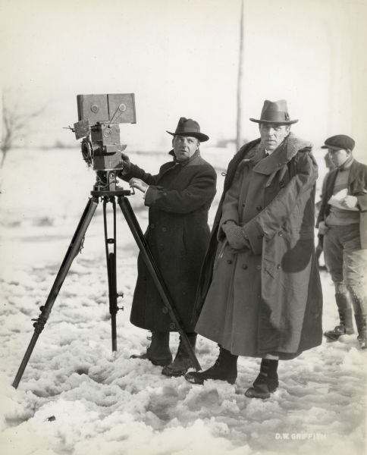

See link for persmissions, if necessary :   
<http://www.wisconsinhistory.org/whi/fullRecord.asp?id=68787>

Also available here : <http://en.wikipedia.org/wiki/File:Billy_Bitzer_D_W_Griffith_1920.jpg>

Links to selected works, all in the public domain :

<https://archive.org/details/TheAdventuresOfDollie>

<https://archive.org/details/ADrunkardsReformation>

<https://archive.org/details/TheCountryDoctor1909>

<https://archive.org/details/ACornerInWheat>

<https://www.youtube.com/watch?v=T3vNmprdhJs#aid=P8hoXnEHPbw>

<https://archive.org/details/TheBirthofaNation1080p>

<https://archive.org/details/Intolerance>

<https://archive.org/details/BrokenBlossoms_201312>

<https://archive.org/details/WayDownEast_201312>

<https://archive.org/details/OrphansOfTheStorm_201312>